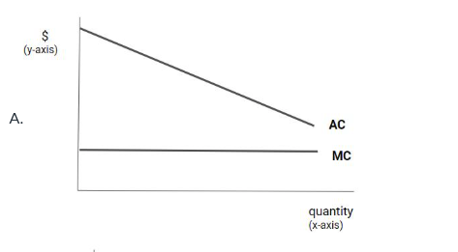
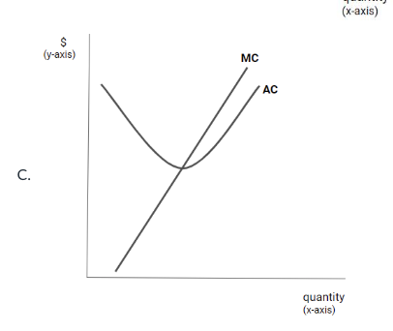
Natural Monopoly
AC declining at market demand→ Natural monopoly Natural monopoly occurs when economies of scale are large enough that one firm can supply the entire market at the lowest cost.市場需求落在 AC curve 下降區 或 economies of scale over entire market = NM
MC < AC → AC falling, MC > AC → AC rising, MC = AC → AC minimum
Average cost curves are decreasing whenever marginal cost is below average cost, and increasing whenever marginal cost is above average cost.

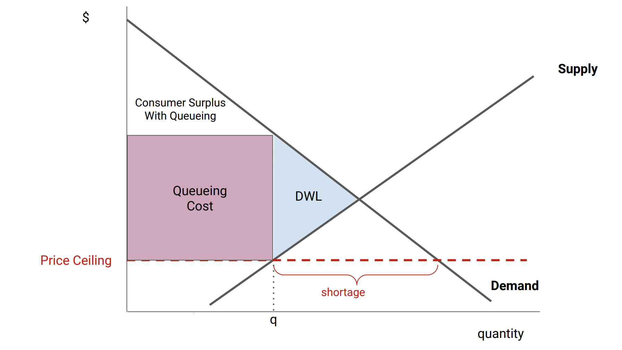
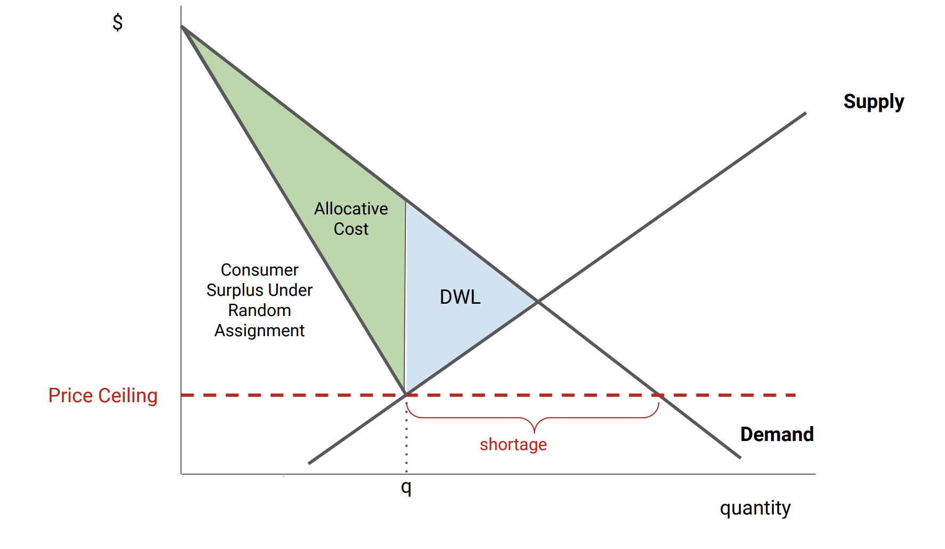
Price Ceiling Effects: Shortage, DWL, Allocative inefficiency
Allocative cost: The welfare loss that occurs when goods are not allocated to the buyers with the highest willingness to pay.
Price ceiling caused shortage & deadweight loss. Secondary market improves allocative inefficiency, but cannot eliminate shortage, deadweight loss still exists

Tax Incidence = who pays tax -> Less elastic side pays more tax 1. inverse demand/supply slope into P=xQ 2. Find slope dP/dQ 3. Inelastic -> pay tax 4. Buyer share= supply slope/ (supply slope) + |demand slope|
Demand inelastic-> buyers pay tax, e,g: insulin/gasoline/electricity buyers buy even high price, Supply inelastic-> sellers pay tax, e.g. land, sellers pay 100%

Averch-Johnson Effect: Rate of return regulation→ capital overinvestment, b/c profit = r × capital, Investor-owned company build infrastructure, expand capacity

Term | 中文 | 核心意思 | English
Rate Base | 計價資產 | 可賺回報的資產 | current total value of a regulated company’s capital investments
Rate of Return | 允許報酬率 | 監管允許的利潤 | compensation a regulated company receives for the oppty cost of its capital investments
Cost of Capital | 資本成本 | 投資最低要求回報 | The minimum return that a company needs on a capital investment
Used & Useful | 已使用原則 | 必須在運作 | A requirement that capital assets be in operation before entering the rate base
Depreciation | 折舊 | 資產價值下降 | One of the biggest expenses for many regulated companies

Double Marginalization: When multiple firms in a vertical chain each add their own markup, resulting in a higher final price and reduced total output. Only occurs when both parties have market power. Monopoly upstream + monopoly downstream.
Natural Monopoly Regulation (efficient P = MC, nut Natural monopoly → MC pricing 不可行（會虧）
C = F + cQ, Demand given, MC=c

P=MC, efficient cost-> but firm cannot pay fix costs, profit <0, profit= - fixed cost

P=AC, profit=0,
- Two-part tariff, P=MC + Fixed fee, per-unit price = MC, fixed fee = consumer surplus 1.用 demand 找 Q 2. 畫 triangle算 CS （D下, P=mc 以上)
- P>MC, create DWL(先找 題目regulated Qty, 再找 efficient Qty（設 P=MC）再用三角形面積算 DWL
